dadmtools: new rasterization options
Oct 22, 2026

What's new
The maj_raster branch (remotes::install_github('bcgov/FAIB_DADMTOOLS', ref = 'maj_raster') lets you choose how each vector dataset is rasterized onto the 1 ha gr_skey grid. It also adds a new function that gives the percentage of each cell covered by a polygon layer.
There are three rasterization methods. Each can be set per function call, or per dataset in config_parameters.csv:
- Cell center (default, unchanged): a feature gets a cell only if it covers the cell's center point.
- Touches (touches = TRUE): every cell a line or polygon touches is burned in.
- Largest area (largest_area = TRUE): each cell gets the polygon covering the largest share of it. The uncovered part of the cell competes as nodata.
Function | What changed
import_to_pg_gr_skey | New touches and largest_area arguments. Oracle layers are now rasterized with GDAL straight from Postgres. With largest_area = TRUE, only pgid and geometry are read into R. Table comments record the method used.
batch_import_to_pg_gr_skey | Reads two new config_parameters.csv columns, rasterization_touches and rasterization_largest_area, for each row. The function's touches and largest_area arguments become the defaults for blank cells.
rasterize_pct_cover (new, exported) | Writes a tif of the percent (0 to 100) of each cell covered by any polygon in a layer. Has an overlap_free fast path.
rasterize_r (new, exported) | R rasterizer with touches and largest_area. Replaces rasterize_terra inside the package.
rasterize_gdal | New touches (gdal_rasterize -at) and largest_area arguments, plus sql for running a query as-is.
pg_to_seles_tif, batch_pg_to_seles_tif | New touches and largest_area arguments, passed to rasterize_r.
ogr_to_tbl | New keep_geom argument, used for the largest-area staging import.

Choosing a rasterization method
Use cell center for most layers, touches for lines and narrow features you must not lose, and largest_area when cell assignment should follow which polygon covers most of the cell. The figure shows the three methods on the same four polygons. It was made with the package's own rasterize_r on a 10 x 6 grid of 1 ha cells.
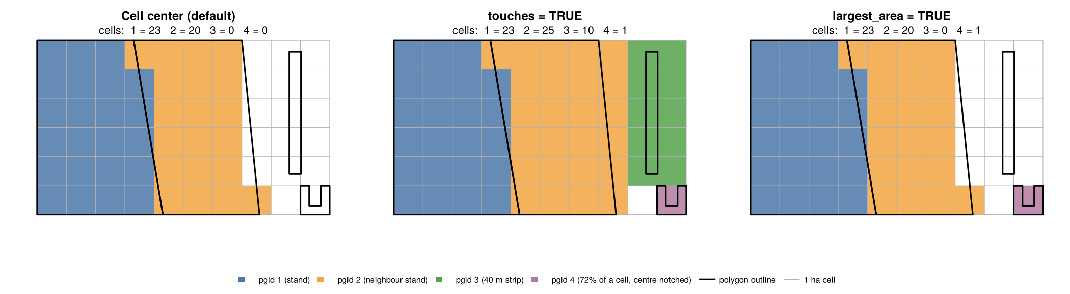
What the figure shows:
- The 40 m strip (pgid 3) never covers a cell centre, so cell center and largest area both drop it. Touches burns 10 cells for it, which is 10 ha for a feature of about 1.7 ha.
- The notched polygon (pgid 4) covers 72% of its cell, but the notch sits over the centre. Cell center misses it, while largest area keeps it.
- The slanted shared edge splits cells between pgid 1 and 2. Cell center decides each split cell by where its centre falls. Largest area decides by which polygon covers more of it. On real layers these two disagree on a share of boundary cells.
Method | A cell gets a feature when | Overlapping features | Good for | Watch out for
Cell center (default) | The feature covers the cell's centre point | Higher pgid wins | Most polygon layers; fastest | Features narrower than a cell can vanish
touches = TRUE | The feature touches the cell at all | Higher pgid wins | Roads, streams, narrow buffers you must keep | Inflates area: every boundary cell is counted
largest_area = TRUE | The feature covers the largest share of the cell, and more than the uncovered share | Polygon covering more of the cell wins | Stand or zone layers where boundary cells should follow area | Polygons only; slower (about 1 ms per polygon, roughly 1 to 1.5 hours for full VRI)
How largest area decides a cell. The uncovered part of a cell competes like a polygon, and no share needs to be over half:
- A cell 49% polygon A, 25% B and 26% uncovered gets A.
- A cell 26% A, 25% B and 49% uncovered is nodata.
On an exact tie between two polygons, the lower pgid wins. On a tie between a polygon and nodata, the polygon wins. Coverage is calculated exactly with exactextractr, not by sampling.
touches and largest_area cannot both be TRUE for the same dataset.

Setting the method per dataset in config_parameters.csv
Each row of config_parameters.csv now picks its own rasterization method, so one batch run can mix methods. The two new columns sit after overlap_group_fields:
- rasterization_touches
- rasterization_largest_area
This example imports three layers, each a different way:
include,overlap_ind,src_type,src_path,src_lyr,dst_schema,dst_tbl,query,flds_to_keep,overlap_group_fields,rasterization_touches,rasterization_largest_area,notes
1,FALSE,oracle,bcgw,WHSE_ADMIN_BOUNDARIES.ADM_NR_DISTRICTS_SP,whse,adm_nr_districts_sp,,,,FALSE,FALSE,cell center (default)
1,FALSE,gdb,C:\data\roads.gdb,road_segments,whse,road_segments,,,,TRUE,FALSE,keep every cell a road crosses
1,FALSE,oracle,bcgw,WHSE_FOREST_VEGETATION.VEG_COMP_LYR_R1_POLY,whse,veg_comp_lyr_r1_poly,,,,FALSE,TRUE,boundary cells follow the larger stand
Then run the batch as before:
library(dadmtools)
batch_import_to_pg_gr_skey(
in_csv = 'C:\\projects\\config_parameters.csv',
out_tif_path = 'C:\\projects\\output\\'
)
Before each vector import, the log prints the method, for example Rasterization method for whse.veg_comp_lyr_r1_poly: largest area.
Values and defaults:
- Accepted values are TRUE / FALSE, 1 / 0, T / F and yes / no.
- A blank cell uses the function's argument, which defaults to FALSE. For example, batch_import_to_pg_gr_skey(..., largest_area = TRUE) turns on largest area for every row whose cell is blank.
- An older csv without the two columns still works. Every row then uses the function arguments.
- Raster rows (src_type = raster) ignore both columns.
Problem rows are skipped, and the rest of the batch keeps running. The skipped rows are listed in the error summary at the end. A row is skipped when:
- both columns are TRUE, or
- either column has a value it can't read, such as maybe.

Example: touches = TRUE
Use touches = TRUE when losing a narrow feature is worse than overstating its area. Typical cases are roads, streams and riparian buffers. This imports a road layer and burns every hectare a road segment touches:
library(dadmtools)
import_to_pg_gr_skey(
src_type = 'gdb',
src_path = 'C:\\data\\roads.gdb',
src_lyr = 'road_segments',
dst_tbl = 'road_segments',
query = '',
flds_to_keep = 'road_class,surface',
notes = 'touches: every cell a road crosses',
overlap_ind = FALSE,
overlap_group_fields = '',
out_tif_path = 'C:\\projects\\output\\',
dst_schema = 'whse',
touches = TRUE
)
The same option works when rasterizing an sf object yourself, for example to preview a layer before importing it:
roads <- sf::st_read('C:/data/roads.gdb', layer = 'road_segments')
roads$id <- seq_len(nrow(roads))
rasterize_r(
src_sf = roads,
field = 'id',
template_tif = 'S:\\FOR\\VIC\\HTS\\ANA\\workarea\\PROVINCIAL\\bc_01ha_gr_skey.tif',
crop_extent = c(273287.5, 1870587.5, 367787.5, 1735787.5),
out_tif_path = 'C:/projects/output',
out_tif_name = 'roads_touches.tif',
datatype = 'INT4U',
touches = TRUE
)
Points to keep in mind:
- Area is overstated. A cell counts as 1 ha however little of it the feature touches. In the figure, the 1.7 ha strip became 10 ha. Don't sum touches cells as an area estimate.
- Neighbouring polygons claim each other's boundary cells. Shared boundary cells go to the higher pgid, so polygon layers gain cells along every edge. In the figure, pgid 2 went from 20 cells to 25.
- Inside the package it runs as gdal_rasterize -at for file and Oracle sources, and as terra::rasterize(touches = TRUE) in rasterize_r.

Example: largest_area = TRUE
Use largest_area = TRUE for stand or zone layers where a boundary cell should go to whichever polygon covers most of it. GDAL can't do this, so the package rasterizes in R with exactextractr. It brings in only pgid and geometry, keeping memory down. This imports VRI from the BCGW:
library(dadmtools)
import_to_pg_gr_skey(
src_type = 'oracle',
src_path = 'bcgw',
src_lyr = 'WHSE_FOREST_VEGETATION.VEG_COMP_LYR_R1_POLY',
dst_tbl = 'veg_comp_lyr_r1_poly',
query = '',
flds_to_keep = NA,
notes = 'largest area',
overlap_ind = FALSE,
overlap_group_fields = '',
out_tif_path = 'C:\\projects\\output\\',
dst_schema = 'whse',
largest_area = TRUE
)
For a gdb, shapefile or geopackage, the call is the same with src_type, src_path and src_lyr pointing at the file.
How it runs for Oracle sources:
- The attribute table whse.<dst_tbl> is built from the foreign data wrapper (FDW) table, and pgid is assigned there.
- A query joins the FDW geometry to that table on objectid and returns pgid plus geometry only.
- Those two columns are read into R in pgid order and passed to rasterize_r(largest_area = TRUE).
How it runs for gdb, shapefile and geopackage sources:
- ogr2ogr imports the layer once, with geometry, into a staging table load.<dst_tbl>_stage. pgid is assigned in this step.
- whse.<dst_tbl> is copied from the staging table without geometry. It has the same columns as a normal import.
- Only pgid and geometry are read from the staging table into R and rasterized.
- The staging table is dropped when the import finishes, including if it fails partway.
Why pgid stays consistent: in both routes pgid is created once and never renumbered. The geometry is read back together with that pgid, from the attribute table (Oracle) or from the same staging row (files). With largest_area = FALSE, nothing changes: geometry never goes into Postgres, and GDAL rasterizes the file or the FDW query directly.
To check an import, run both queries. Each should return 0:
-- every pgid in the gr_skey table exists in the attribute table
SELECT count(*) FROM whse.veg_comp_lyr_r1_poly_gr_skey k
LEFT JOIN whse.veg_comp_lyr_r1_poly a USING (pgid) WHERE a.pgid IS NULL;
-- no duplicate objectid in the attribute table (Oracle sources)
SELECT count(*) FROM (SELECT objectid FROM whse.veg_comp_lyr_r1_poly
GROUP BY objectid HAVING count(*) > 1) d;
With overlap_ind = TRUE, each overlap group is selected in SQL and rasterized separately by largest area. Within a group, the polygon covering more of the cell wins.
Memory and time:
- Besides the geometry, R holds three integer arrays the size of the output grid. For the full provincial extent that's about 2.6 GB.
- Lower chunk_size in rasterize_r if you run short of memory.
- Expect roughly 1 ms per polygon.

rasterize_pct_cover: percent of each cell covered
rasterize_pct_cover writes a tif where each 1 ha cell holds the percent (0 to 100) of its area covered by any polygon in a layer. Attribute values are ignored. Coverage is exact (exactextractr), and the output is written one band of rows at a time, so memory stays small even for the whole province.
overlap_free defaults to FALSE. Switch it TRUE only for layers you know have no overlaps. Having overlap_free set to TURE exponentially increase speed of the process since no dissolving needs to be done in R.
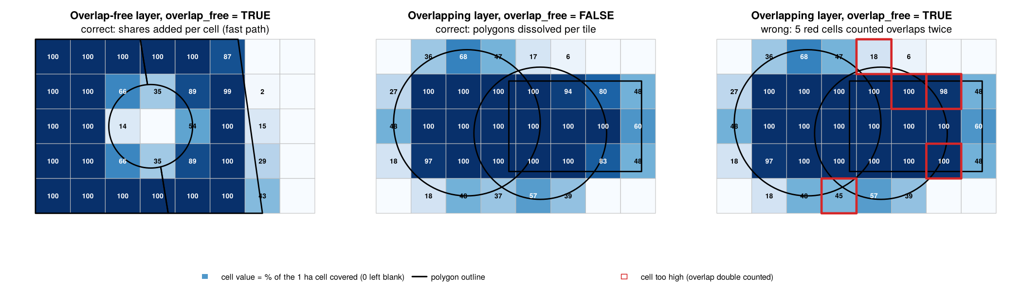
- Left: two stands with a non-forest gap. The fast path is exact here because no polygons overlap.
- Middle: overlapping polygons with overlap_free = FALSE. Each tile is dissolved first, so overlaps are counted once.
- Right: the same overlapping polygons with overlap_free = TRUE. Five cells come out too high, by up to 18 percentage points, because overlaps are added twice. Values never come out too low, and are capped at 100.
Example: overlap_free = TRUE, for a layer with no overlaps such as VRI:
library(dadmtools)
rasterize_pct_cover(
src_sf = 'C:/data/vri.gdb',
src_lyr = 'veg_comp_lyr_r1_poly',
where = "bclcs_level_2 = 'T'", # treed polygons only
out_tif_path = 'C:/projects/output',
out_tif_name = 'vri_treed_pct_cover.tif',
overlap_free = TRUE # the default; VRI polygons do not overlap
)
Example: overlap_free = FALSE, for a layer that overlaps:
fires <- sf::st_read('C:/data/fires.gdb', layer = 'fire_perimeters')
rasterize_pct_cover(
src_sf = fires,
out_tif_path = 'C:/projects/output',
out_tif_name = 'burned_pct_cover.tif',
datatype = 'FLT4S', # keep decimals
overlap_free = FALSE # perimeters from different years overlap
)
Argument | Default | Notes
src_sf | none | sf object, or path to a gdb, geopackage or shapefile
src_lyr, where | NULL | Layer name and attribute filter when src_sf is a path
template_tif | provincial bc_01ha_gr_skey.tif | Defines the grid
crop_extent | provincial extent | c(xmin, xmax, ymin, ymax) in EPSG:3005
datatype | 'INT1U' | Whole percents; cells under 0.5% round to 0. Use 'FLT4S' for decimals
nodata | 0 | Uncovered cells are written as nodata
overlap_free | TRUE | FALSE dissolves per tile and is always correct
tile_size | 50000 (m) | Smaller uses less memory and makes dissolving cheaper
Speed. On a VRI-like test layer of 20,000 polygons over 1 million cells, overlap_free = TRUE took 5.6 seconds and FALSE took 14.7 seconds. Both gave the same answer to within 0.0001 percentage points.
Getting it into Postgres. Import the tif as a raster, and each cell's percent lands in a gr_skey table:
import_to_pg_gr_skey(
src_type = 'raster', src_path = 'C:/projects/output/vri_treed_pct_cover.tif', src_lyr = 'pct_cover',
dst_tbl = 'vri_treed_pct_cover', query = '', flds_to_keep = NA, notes = '',
overlap_ind = FALSE, overlap_group_fields = '', out_tif_path = 'C:\\projects\\output\\', dst_schema = 'whse'
)

Table comments record the method
Every table import_to_pg_gr_skey creates now says how it was rasterized. That applies to both the attribute table and its _gr_skey table. To see it:
SELECT obj_description('whse.veg_comp_lyr_r1_poly_gr_skey'::regclass);
The comment ends with a section like this, here for a largest-area import:
Rasterization details:
Method: largest area - each cell gets the polygon covering the largest share of it; the uncovered share competes as nodata (rasterize_r / exactextractr)
Overlaps: not kept - where features overlap, the one covering more of the cell wins
Cell size: 100 m (1 ha) gr_skey grid
Import | Method line | Overlaps line
Default | cell center (gdal_rasterize) | not kept, higher pgid wins
touches = TRUE | all touched (gdal_rasterize -at) | not kept, higher pgid wins
largest_area = TRUE | largest area (rasterize_r / exactextractr) | not kept, the polygon covering more of the cell wins
overlap_ind = TRUE | whichever method was used | kept, each combination of the overlap group fields rasterized separately
Raster source | none, cell values used as-is | not applicable
Oracle imports now burn features in pgid order, so "higher pgid wins" holds for Oracle as well as file sources.

Notes, limitations and upgrade checklist
Limitations:
- largest_area works on polygons only, and cannot be combined with touches.
- Largest area on a gdb, shapefile or geopackage temporarily stores a full copy of the geometry in load.<dst_tbl>_stage. For VRI that's several GB.
- The staging import reprojects to EPSG:3005, so a source with no CRS (for example a shapefile without a .prj) fails there.
- The staging import names its geometry column geom, so a source field already called geom will clash.
- rasterize_pct_cover reads every column of a file source before dropping them, so a very wide layer still uses RAM at load time.

